Clear Workspace
close all;
clear;
clc;

Given Data
FZ = 4000; % Vertical load (N)
SA = deg2rad(4); % Slip angle (rad)
u = 0.6; % Coeff. of friction
a = 0.16/2; % Half patch length (m)
C = 3.5e6; % Cornering stiffness (N/m^2)

Calculate Intermediate Terms
S = tan(SA); % Lateral slip
T = (2*a^2*C)/(3*u*FZ); % Theta
xs = 2*a*(1-T*S); % Begining of sliding region
Gxs = (2*a-xs)/(2*a*T); % Gamma(xs)/xs

Question A
FY1 = []; FY2 = []; FY3 = []; FY4 = [];
for lw = linspace(0,2*a,100)
if lw < xs % 0 <= lw < xs
dFY1 = @(x) C.*x.*Gxs;
FY1(end+1) = integral(dFY1,lw,xs);
dFY2 = @(x) (C.*x.*(2.*a-x))/(2.*a.*T);
FY2(end+1) = integral(dFY2,xs,2*a);
FY3(end+1) = FY1(end) + FY2(end);
else % xs <= lw <= 2a
dFY4 = @(x) (C.*x.*(2.*a-x))/(2.*a.*T);
FY4(end+1) = integral(dFY4,lw,2*a);
end
end
FY = [FY3 FY4];
lw = linspace(0,100,100);
figure(1)
plot(lw,FY,'color','red')
xlabel('${l_w}$ (\%)','interpreter','latex')
ylabel('${F_y}$ (N)','interpreter','latex')
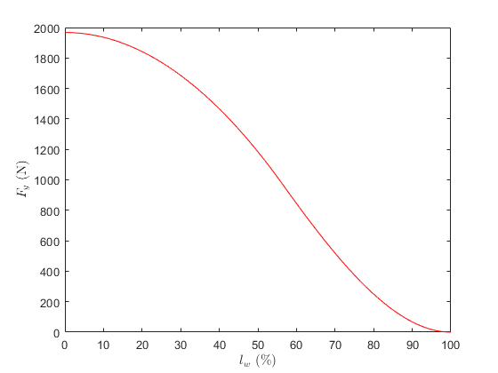

Explanation
As 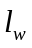 increases (i.e., as increasing portion of tire contact patch undergoes hydroplaning), the lateral force production capacity of the tire tread elements decreases (which is what we can clearly observe from the plot above). When is 0, we observe maximum lateral force (corresponding to one which we obtain from the original analytical tire model with parabolic pressure distribution, i.e., disregarding the hydroplaning effect). When 100% of the tire patch length, we observe 0 lateral force, which is the expected behavior since all tread elements are undergoing hydroplaning.

Question B
MZ1 = []; MZ2 = []; MZ3 = []; MZ4 = [];
for lw = linspace(0,2*a,100)
if lw < xs % 0 <= lw < xs
dMZ1 = @(x) C.*x.*Gxs.*(a-x);
MZ1(end+1) = -integral(dMZ1,lw,xs);
dMZ2 = @(x) (C.*x.*(2.*a-x).*(a-x))./(2.*a.*T);
MZ2(end+1) = -integral(dMZ2,xs,2*a);
MZ3(end+1) = MZ1(end) + MZ2(end);
else % xs <= lw <= 2a
dMZ4 = @(x) (C.*x.*(2.*a-x).*(a-x))/(2.*a.*T);
MZ4(end+1) = -integral(dMZ4,lw,2*a);
end
end
MZ = [MZ3 MZ4];
lw = linspace(0,100,100);
figure(2)
plot(lw,MZ,'color','blue')
xlabel('${l_w}$ (\%)','interpreter','latex')
ylabel('${M_z}$ (Nm)','interpreter','latex')
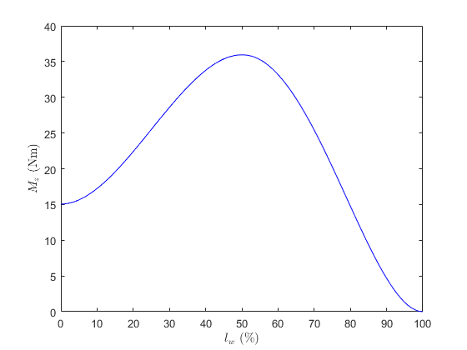

Explanation
As increases from 0 to 50% of the tire patch length, the contribution of individual negative (CW) self-aligning torques to the total self-aligning torque keeps decreasing, because of which, the total self-aligning torque keeps increasing. However, as further increases from 50% to 100% of the tire patch length, the contribution of individual negative (CW) self-aligning torques becomes 0 and that of individual positive (CCW) self-aligning torques to the total self-aligning torque starts decreasing, because of which, total self-aligning torque starts decreasing, ultimately falling to 0, as indicated by above plot.

Question C
e = MZ./FY;
lw = linspace(0,100,100);
figure(3)
plot(lw,e,'color','magenta')
xlabel('${l_w}$ (\%)','interpreter','latex')
ylabel('${e}$ (m)','interpreter','latex')
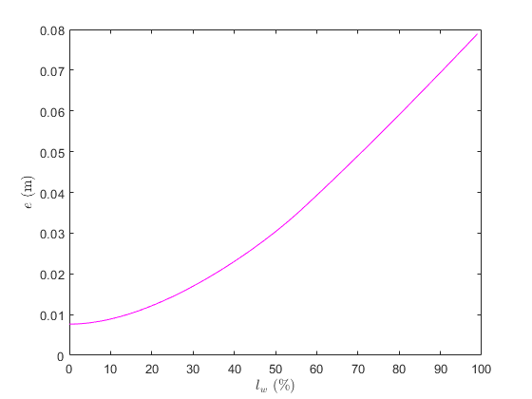

Explanation
As increases, the lateral forces on individual tread elements between 0 and 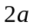 keeps dropping (under hydroplaning condition, the tread element cannot produce lateral force), because of which, the resultant lateral force keeps shifting to the right (from to ), thereby increasing the pneumatic trail continuously. This is what we observe from the plot above as increases from 0% to 99% of the tire patch length. However, as becomes 100% of the tire patch length, both lateral force as well as self-aligning torque become 0, because of which, pneumatic trail becomes undefined (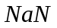in MATLAB) and hence is not observed in the plot above.

Published with MATLAB® R2022a

